Amplify Reading Data Analysis

Sample data
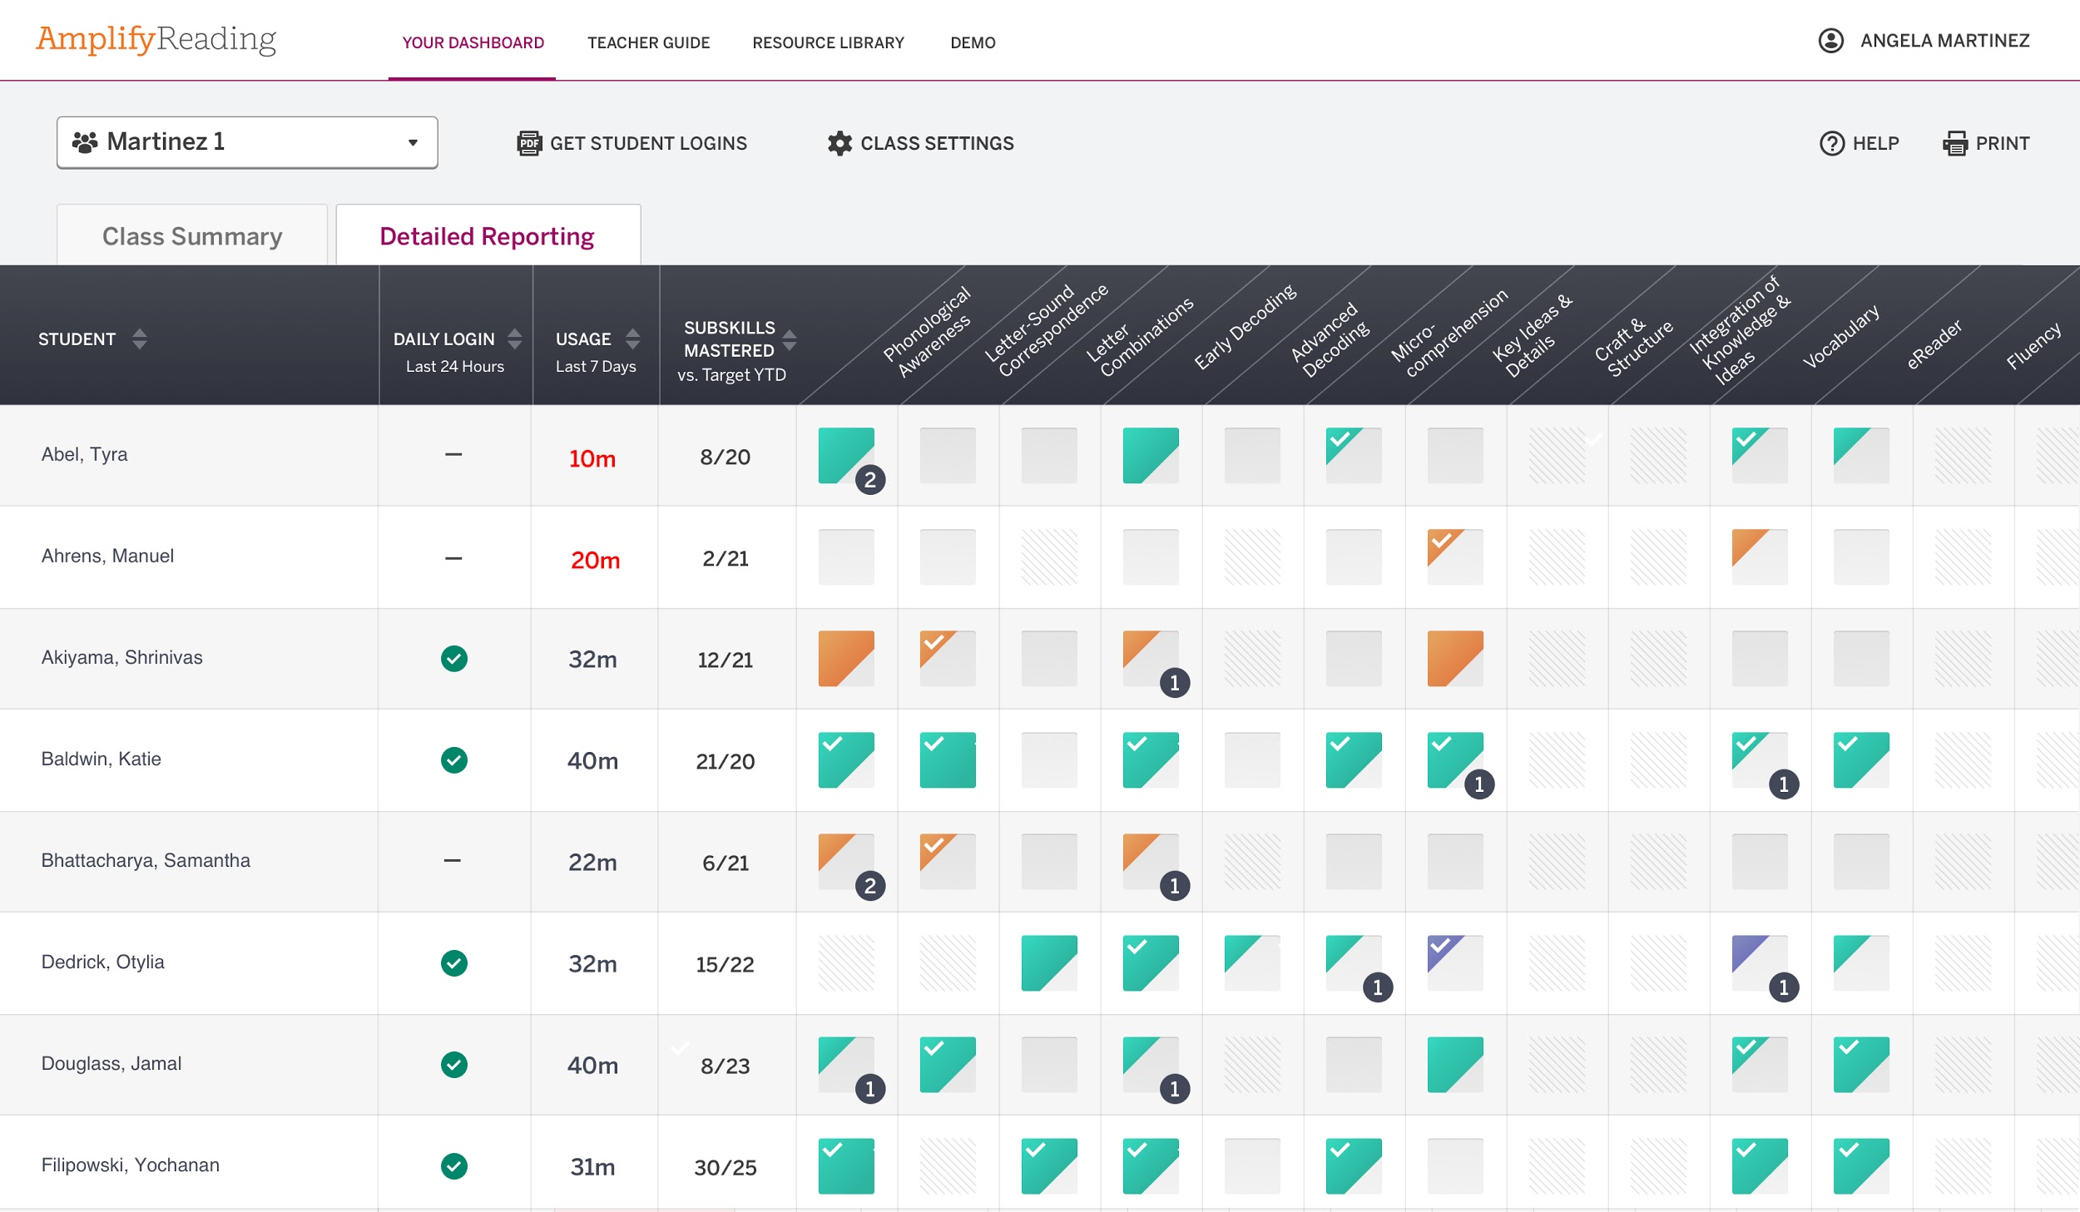

Now it’s your turn!

Whole class analysis
Celebrations

- Which domains, as indicated by few or no trouble spots in the skill domains, are areas of strength for your class?
𝤿 Phonological Awareness
𝤿 Letter-Sound Correspondence
𝤿 Letter Combinations
𝤿 Early Decoding
𝤿 Advanced Decoding
𝤿 Comprehension Processes
𝤿 Key Ideas & Details
𝤿 Craft & Structure
𝤿 Integration of Knowledge & Ideas
𝤿 Vocabulary
𝤿 eReader
𝤿 Fluency
𝤿 Close Reading

- List all of the students who have no trouble spots (i.e., are making progress in Amplify Reading without more support needed for specific skills.)

Areas for support
- Are there any students who have not used Amplify Reading? Or, are there any students who are not meeting your usage expectations? For example, do expect all students to use Amplify Reading 30 minutes each week?

𝤿 yes
𝤿 no

Students working below grade level in Amplify Reading:

Students not meeting usage expectations:

- List the students who have an identified trouble spot in each of the below skill domains.

Phonological Awareness | Letter-Sound Correspondence | Letter Combinations | Early Decoding | Advanced Decoding | Comprehension Processes

Key Ideas & Details | Craft & Structure | Integration of Knowledge and Ideas | Vocabulary | eReader | Fluency | Close Reading

- Which literacy domains, as indicated by trouble spots, are areas of need for your class? Check the box and write the number of students with this skill need.
𝤿 Phonological Awareness
𝤿 Letter sounds
𝤿 Letter combinations
𝤿 Early decoding
𝤿 Advanced decoding
𝤿 Comprehension Processes
𝤿 Key Ideas & Details
𝤿 Craft & Structure
𝤿 Integration of Knowledge & Ideas
𝤿 Vocabulary
𝤿 eReader
𝤿 Fluency
𝤿 Close Reading

Small group analysis

- Pick one of the skills from above to further explore the needs of students needing support with that skill domain. Complete the table below for that skill.

Skill domain:
Student name | Identified pattern | Notes

- List the students who have a similar pattern or skill need and could be grouped together for instructional support. Start with the most basic skill, and sequence moving up to the most complex.

Skill need: | Skill need: | Skill need: | Skill need: | Skill need:
Names: | Names: | Names: | Names: | Names:

Next steps:
- Identify the different small groups student needs based on this data.

- How will you support their instructional needs? When will you teach these skills?

Student analysis
1. Identify a student who you want to learn more about, and complete the analysis for them below.

Student name:
Skill domains worked in:
Trouble spots:

Trouble spot 1:
Content set mastered:
Content set not mastered:

Trouble spot 2:
Content set mastered:
Content set not mastered:

2. What are the skills you need to support this student with?

3. What changes do you need to make to your instructional plan for this student?

Prioritizing Next Steps

Use the Root Cause Analysis questions below to help you synthesize your understanding of your data and determine next steps.

Root Cause Analysis

- Instruction (All Tiers): Is core instruction being implemented with fidelity? Is intervention in place?
- Scheduling and Time: Are all students that need intervention receiving it? Are students in the correct intervention? How much time is being spent in core instruction and intervention?
- Staffing: Does the allocation of supplemental staff support the instructional needs of all students (both in core and intervention)? Are the most highly qualified teachers leading intervention groups?
- Assessment Practices: Are assessments being given to monitor student progress?
- Effective Data Review Practices: Do staff regularly review current data and know where instruction needs to be for each student?
- Professional Development: Has there been sufficient training on all resources (universal instruction/intervention)? Does instructional staff have a deep knowledge of early literacy skills and how to teach struggling students on the skills?

1. Which skills are students doing well in? What skill domains do students need support in?

2. What can you attribute this to? (Use Root Cause Analysis to help you think about this further.)

3. Which students are not seeing an increase in performance? List them:

4. What can you attribute this to? (Use Root Cause Analysis to help you think about this further.)

5. What next steps do you need to take to improve the performance of every student, or to maintain the improved performance of every student? What changes do you need to make to your instructional plan for whole-group instruction? What changes do you need to make to your instructional plan for small group instruction?

