The

Newsletter

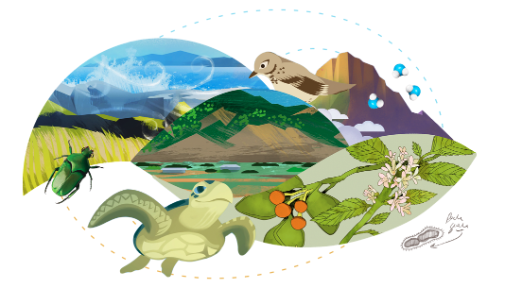

The theme for Earth Day 2021 is Restore Our Earth. There are lots of resources available within Amplify Science to get your students excited. Here are a few that you can use to celebrate with your students:

- The Effects of Climate Change article set (Earth's Changing Climate unit)
- Sunlight and Life article set (Matter and Energy in Ecosystems unit)
- “The Endless Summer of the Arctic Tern” (Earth, Moon, and Sun unit)

Download our Earth Day printable PDF bookmark! Then print and share with your students to save their spot in their current book.

Coming Soon for Back-To-School 2021

We have some exciting enhancements coming for back to school: see a preview below and stay tuned for more information coming as you begin to plan for the next school year!

Spanish Classroom Slides: Classroom Slides for all lessons in 6-8 will be available in Spanish in the 2020-21 school year (K-5 slides already available in English and Spanish). Slides will be released on a rolling basis throughout the 2021-2022 school year following the Integrated Course model.

Classwork Submission Notifications: Teachers will receive alerts on work to review and links to new submissions. Teachers will access student work from multiple classes and provide timely feedback. A bell button will be located in the top right corner of the Classwork banner so teachers can access notifications which link back to the work so teachers can quickly jump into providing feedback for students.

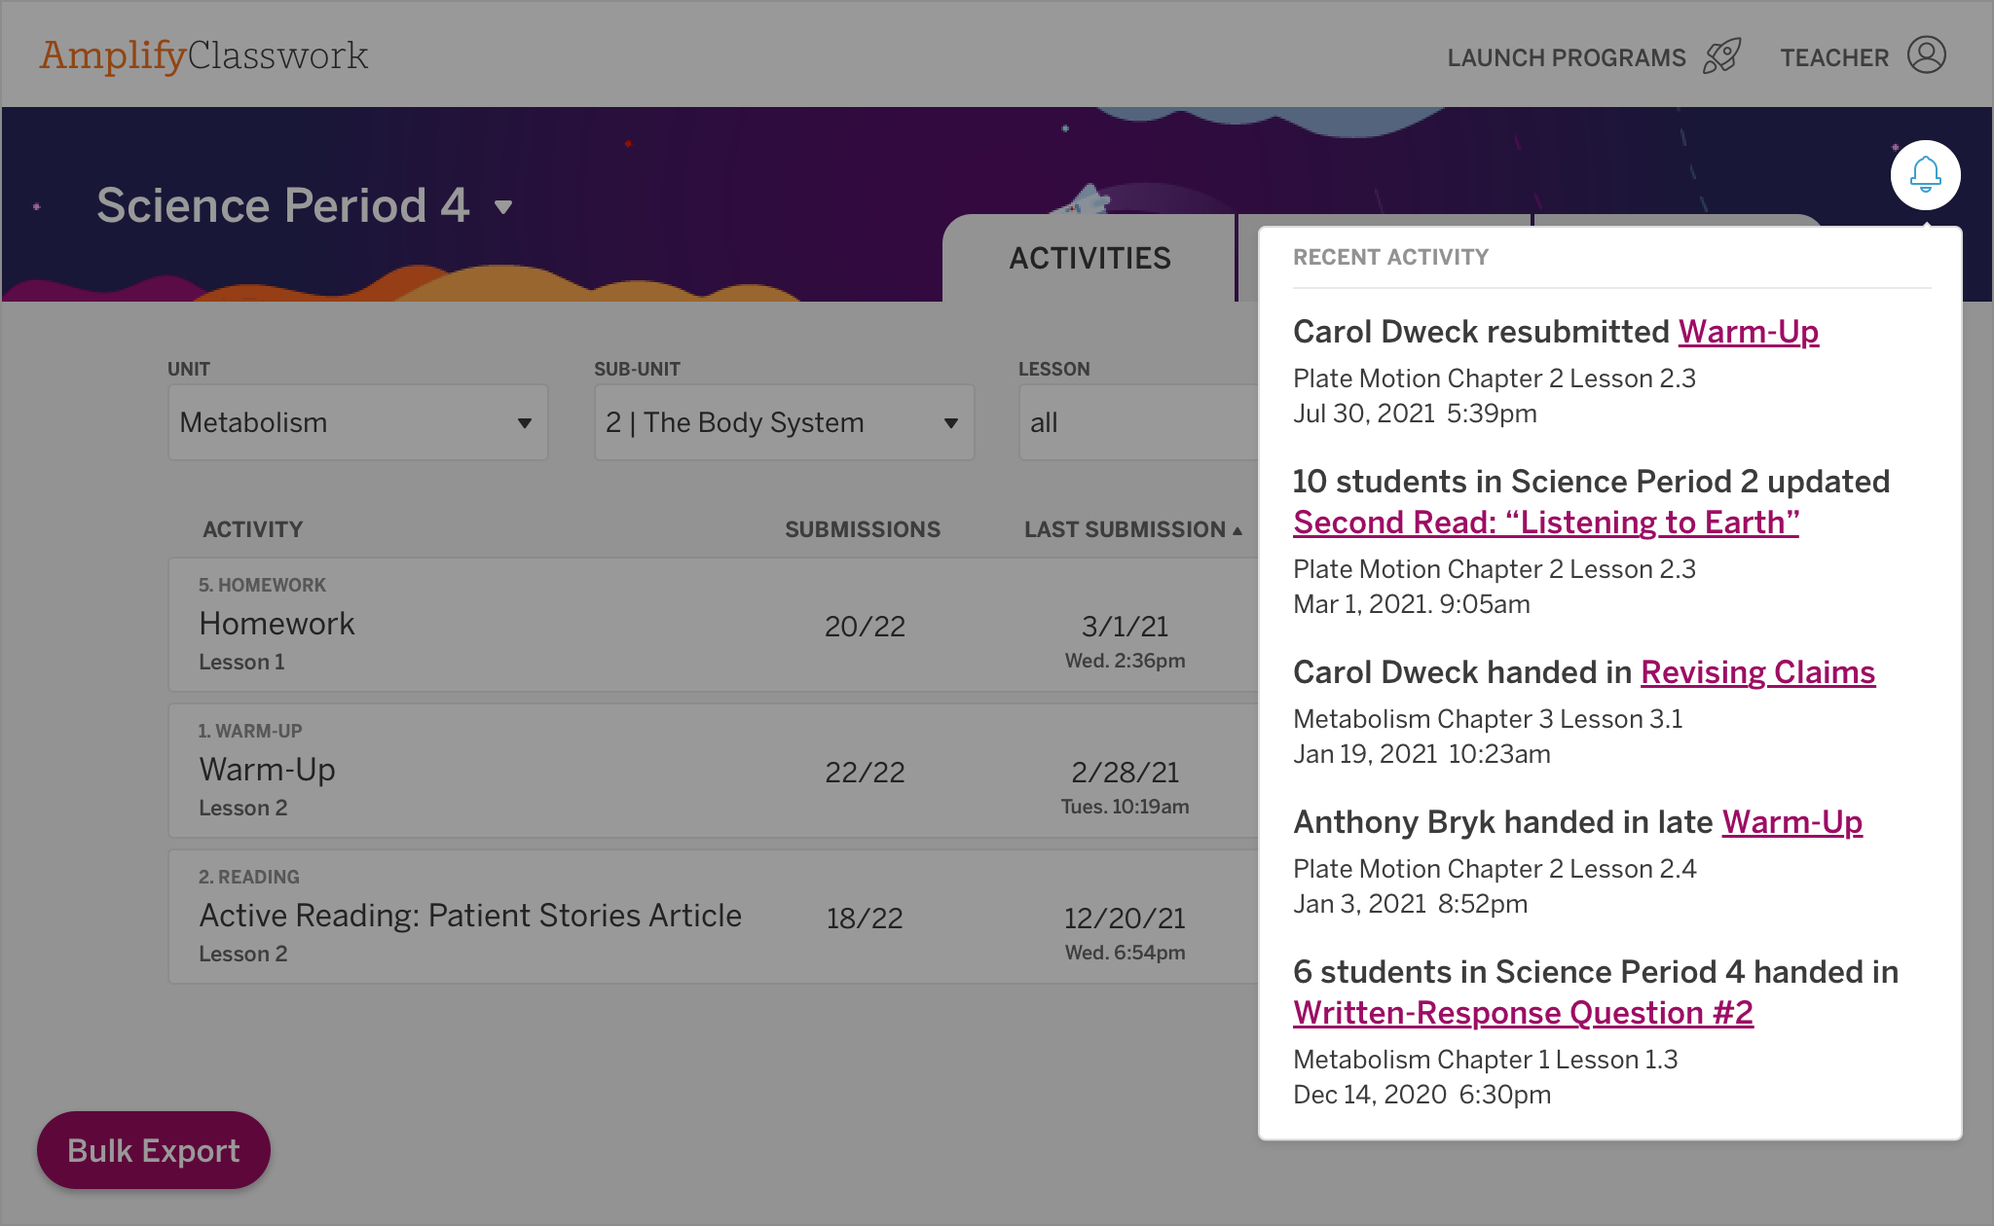

Schoology Grade Sync: Amplify Science for grades 6-8 will now feature Schoology sync functionality beginning Fall 2021. This helpful update will allow the sending of grades from the Amplify Science platform to the learning management grade book you are currently using.

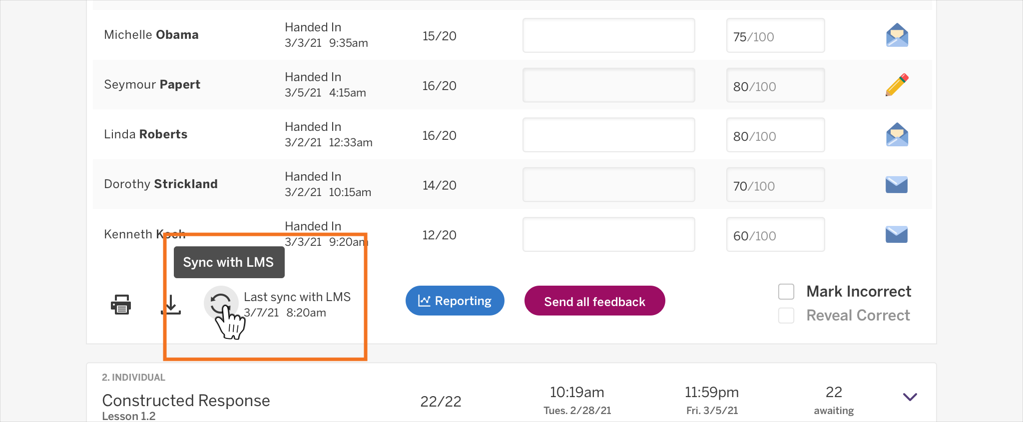

Assign in Microsoft Teams: The “Assign in Microsoft Teams” button offers middle school Amplify Science teachers the flexibility to integrate Amplify content with their class Teams.

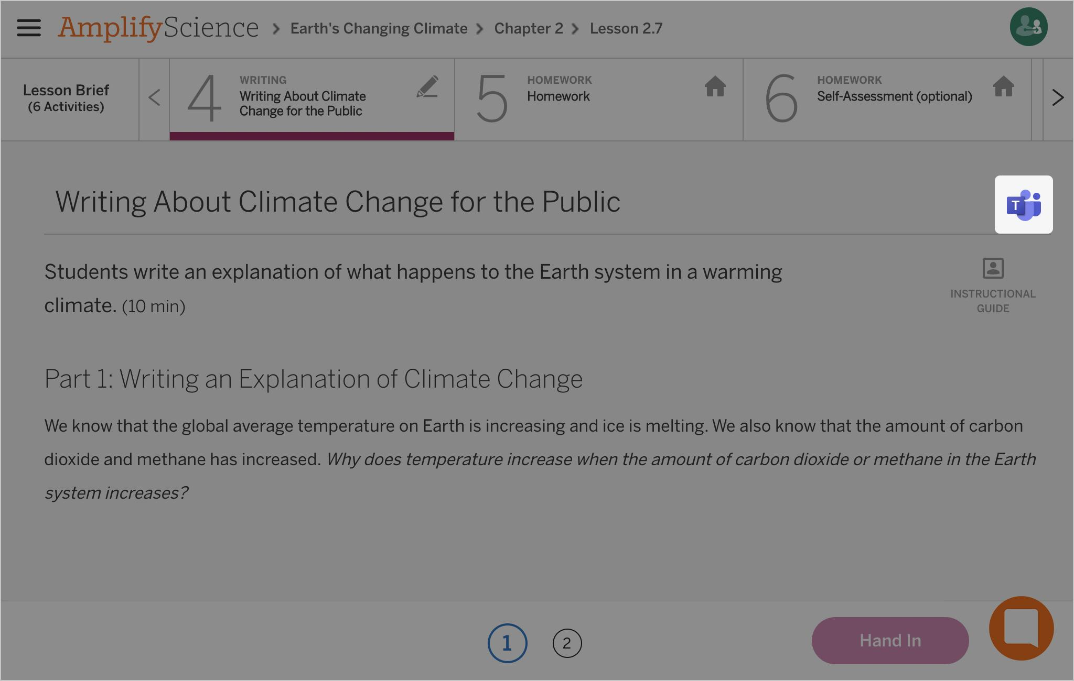

Check out our Coming Soon page to read more about enhancements (automatically updated without additional purchases) and upgrades (requiring additional purchases) for the 2021-2022 school year.
Transitioning to In-Person Learning
If you’re making the transition back to in-person learning from remote instruction, there can be a lot to think about. Below, we’ve outlined some of the top-of-mind considerations we recommend you work through as you’re preparing for your transition.
Considerations:
- Are most of your students returning to in-person learning?
- Do you have access to your physical materials?
- Do you have dedicated science time each week?
- Are your classes synchronous for science instruction?
If you’ve answered no to the above questions, you may want to stay the course with the @Home learning resources for the remainder of the school year. If you need a refresher or additional support, don’t forget there are resources available on the Program Hub under Remote and Hybrid Learning Resources.
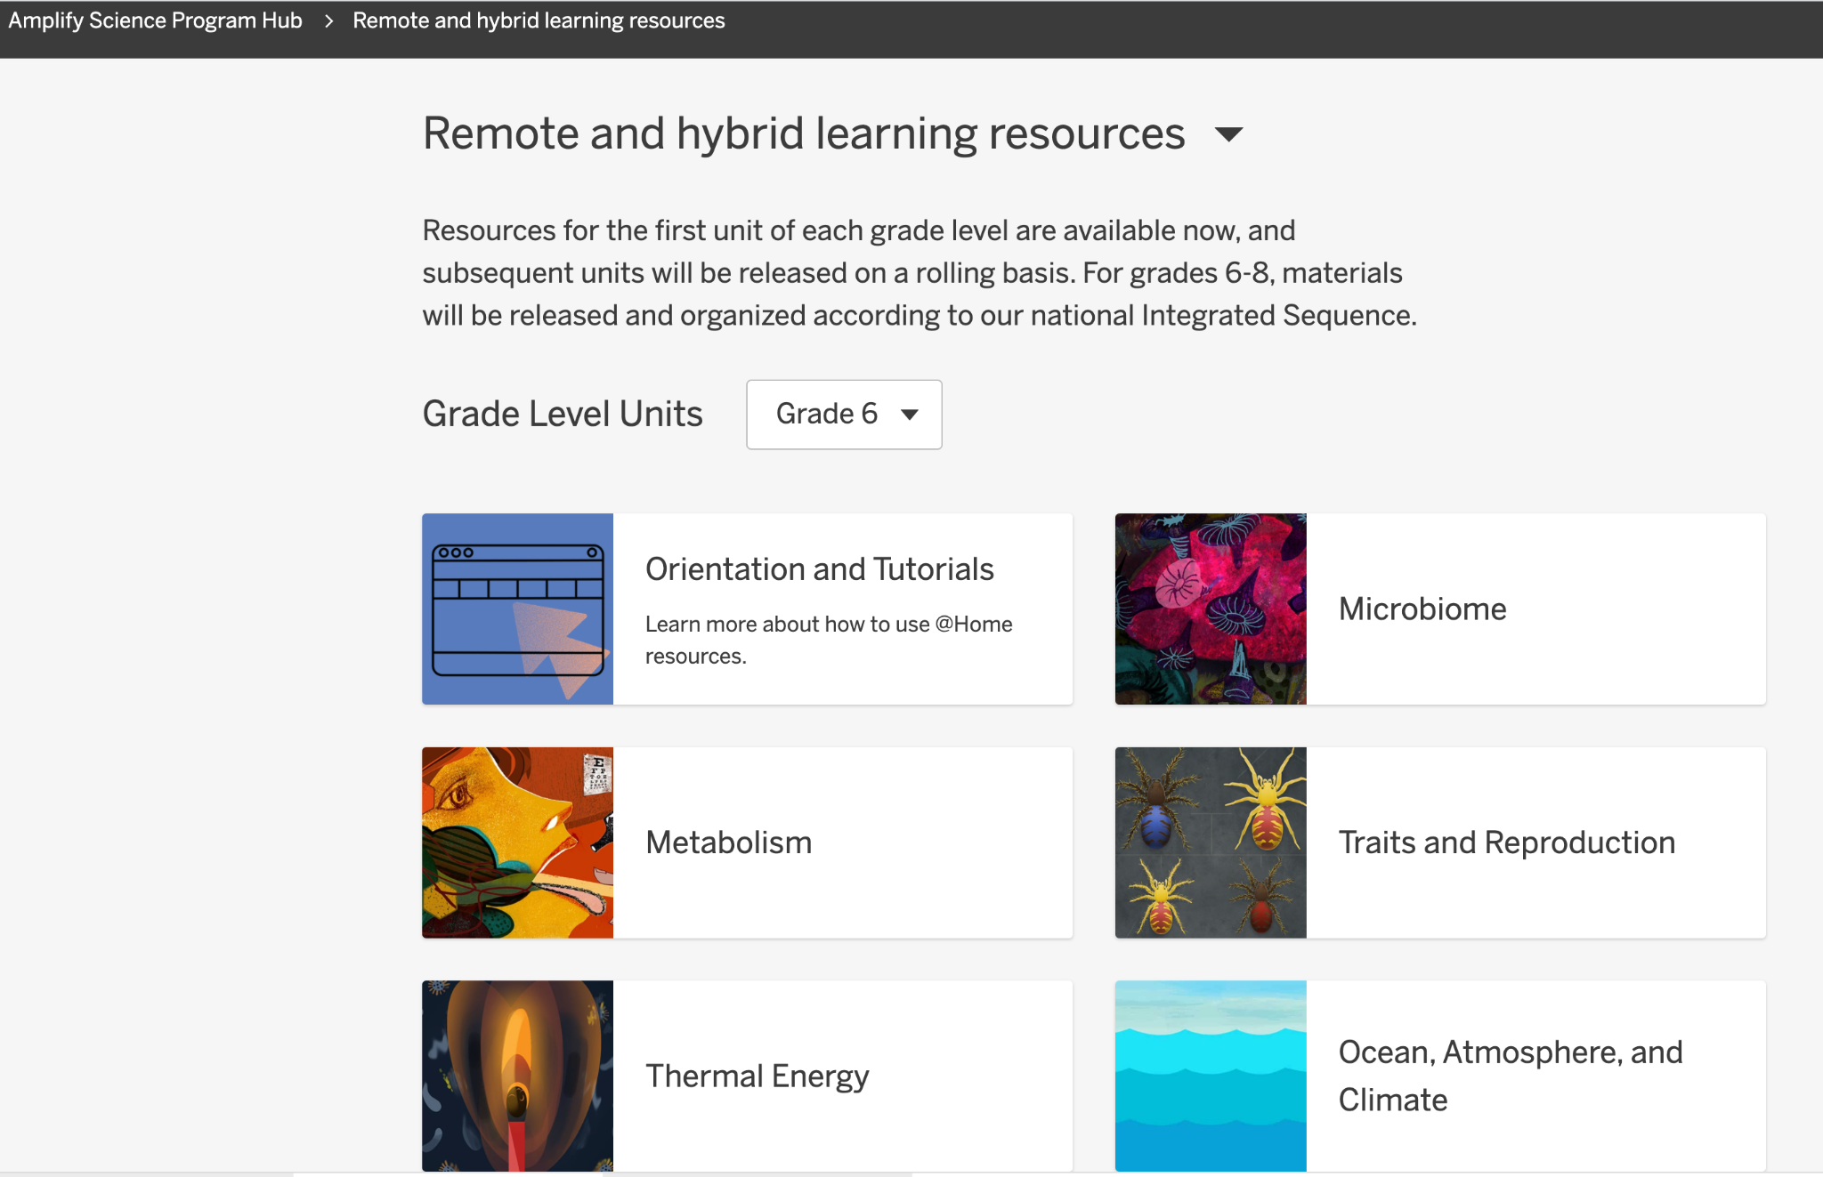

If you answered yes to the above questions, it might be time to transition back to the full curriculum.
What are the benefits of using the standard Amplify Science program?
- Students get access to the full range of phenomenon-based instructional materials that meet the New York State Science Learning Standards. In order to meet the needs of teachers and students, Amplify Science @Home Units were created using 50% of the standard instructional materials.
- Students will have increased time for collaboration and discussion with their peers.
- Students will have increased opportunities for engagement in our multi-modal approach, including hands-on investigations and data collection.
- Students have more opportunities to engage in scientific discourse, an area in which there is great overlap with English Language Arts standards. These opportunities will allow students to strengthen their speaking, writing, and listening skills.
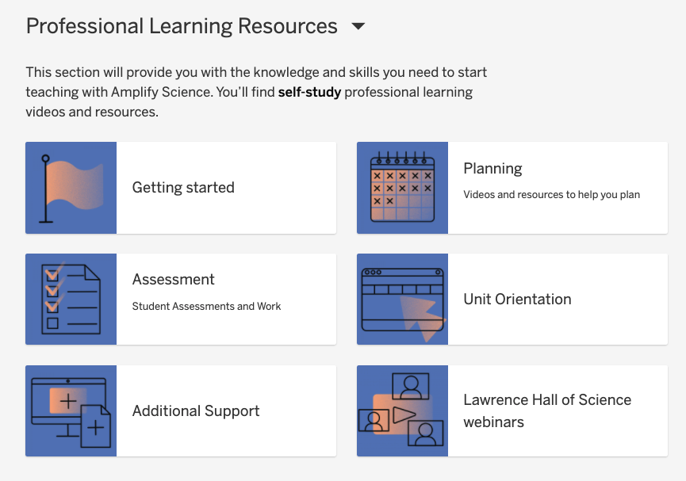

Spotlight

Derek Haider and David Minton, Uinta County School District #1

“Derek and David have done an incredible job digging deep into the resource and getting everything the program has to offer. Their implementation has been outstanding. Each teacher uses the best that Amplify Science has to offer to bring science to life for their students.”

— Doug Rigby, Assistant Superintendent

Submit a nomination!

Each featured educator will receive a special gift from us.
Advice and answers
Have you used the Assign in Amplify feature to distribute activities to your students? Start assigning within the Amplify platform. Learn more here.

Amplify Uptime: Historical uptime for Amplify Science during the month of March was 100%. Learn more about uptime and how to stay informed.

Calendar
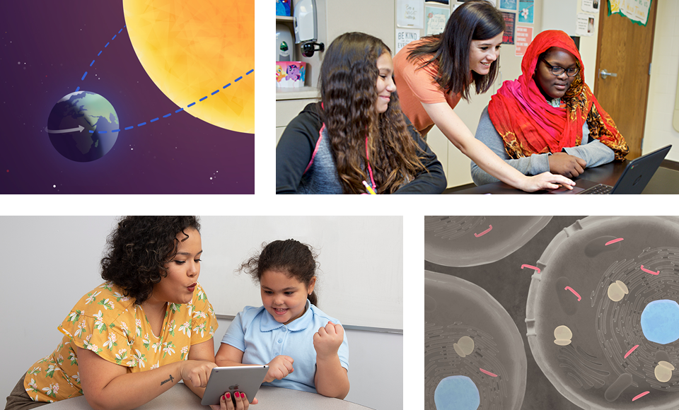

Educator Spotlight Series
Tune in to the upcoming live sessions (and access past recordings) to hear how teachers have used the Amplify Science program to engage their students, create community connections, integrate literacy instruction, and more.
- Wednesday, April 21, 4:00 p.m. ET
- Monday, April 26, 3:30 p.m. ET
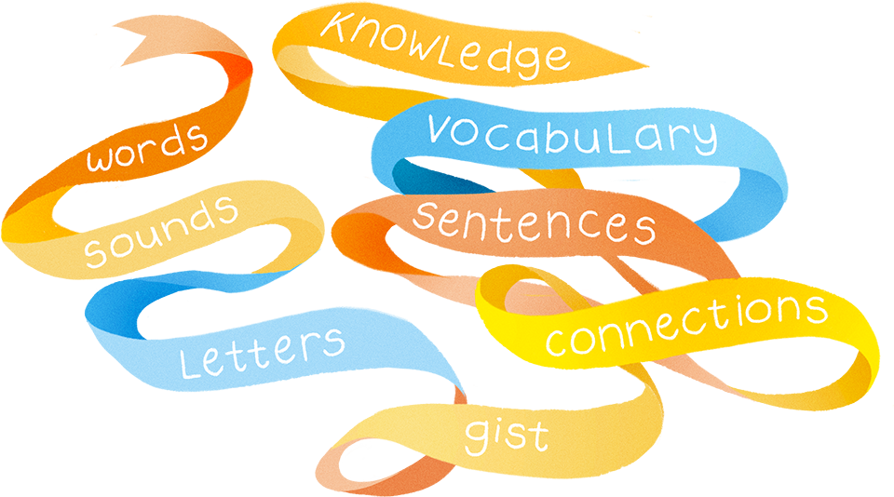
Reading Reimagined: Uncovering the Science Behind Personalized Learning
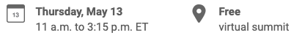
This event is a front-row seat for Amplify users looking to learn more about the future of personalized learning.

Summit topics will include:

- The Science of Reading in personalized learning
- What to look for in a personalized learning program.
- How to leverage COVID-19 relief stimulus funding to combat instructional loss.

...and much, much more! Register now and get your free digital swag bag.

Let’s connect
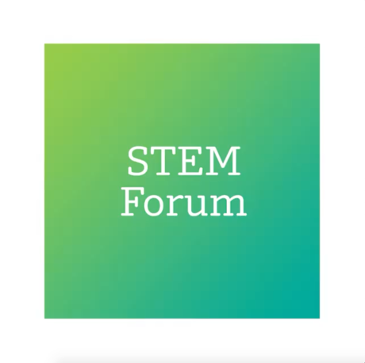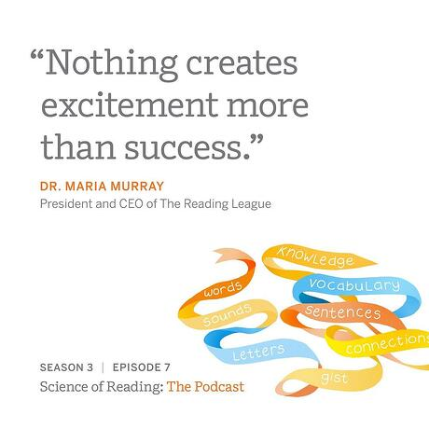

Connect with us—and educators everywhere—on social.

FOLLOW AMPLIFY ON INSTAGRAM›

Facebook
Instagram
Twitter
LinkedIn
YouTube

